**Data Analysis:**

**Questions**

* What's the total charged over this time period?
* What's the most popular handset model?
* What is the mean number of balance inquiries per person?
* What is the mean degree (number of contacts) per person (including incoming and outgoing calls)?
* Which person has the largest asymmetry between incoming and outgoing contacts? How asymmetric is it?

Assumptions/Nuances

* Negative charges for top-ups are ignored (when calculating total charge)
* LineIds 25 and 60 did not make any transactions (not in LineID.From).

**Data Summary**

1. Time period = 1/1/2005 – 2/6/2005
2. Number of people = 100
3. Number of handsets with a model number = 98
4. Definition of contacts = SMS + Calls (unless specifically called out)

**Responses to the Questions**

|  |  |
| --- | --- |
| Total Charged over this time period | 1219619.50  (Represents 1036 calls and 98 SMS) |
| Most popular handset model | Motorola-C113 with 33 handsets (out of 98 handsets with a model name/number) |
| Mean number of balance inquiries per person | 0.96  (Total number of balance inquiries = 96, Number of people = 100) |
| Mean degree of contacts per person (including incoming and outgoing calls) | 20.72 Calls |
| Person with largest asymmetry between incoming and outgoing calls | #5: Nokia-1200  Asymmetry = –27 🡺 Person #5 made 10 calls and received 37 calls |

**Additional Analysis**

1. **Charges (Definition: Contacts = Calls + SMS, doesn’t include topups).**

**[DataFrame:** LineID, Total Charge] where charge is associated with LineID.From

Total Charged = 1219619.50

Mean charge / person = 12196.20

Highest charge / person = 39309 (3.2%)

Lowest charge / person = 670 (0.1%)

Standard Deviation = 8147.20 🡺 68% were charged between 4049 and 20343.40

Coefficient of Variation = 0.7 🡺 there is dispersion

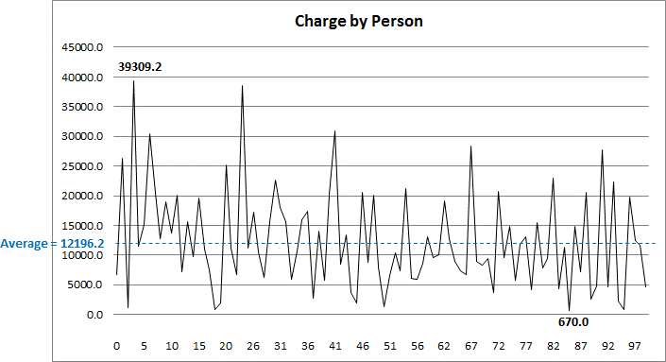

Device model with highest charge = Motorola-C113: 464130.10 (38%)

Device model with lowest charge = Blackberry Curve: 121059.4 (10%)

1. **Handsets**

Number of handsets with a model number = 98

Most popular handset model = Motorola-C113: 33 (34%)

Least popular handset model = Blackberry Curve: 11 (11%)

Most active handset model: Motorola-C113: 11.3 Calls / handset; 12.33 Calls + SMS /handset

Least active handset model: Blackberry Curve: 9.73 Calls / handset; 10.73 Calls + SMS /handset

1. **Transactions (Transactions initiated)**

|  |  |  |
| --- | --- | --- |
| **Transaction** | **# of Transactions** | **# of People** |
| Calls | 1036 (78%) | 98 |
| SMS | 98 (7%) | 51 |
| Balance Inquiries | 96 (7%) | 60 |
| Topups | 107 (8%) | 66 |

1. **Calls**

Number of calls made = 1036

Average number of calls / person = 10.36

By Time of Day

Peak time = 6-7AM: 63 Calls (6.1%)

Lowest = 10-11AM: 33 Calls (3.2%)

Interesting fact: 25% of all calls occurred between 12AM and 6AM

By Day of Week

Peak day = Saturday: 191 calls (18.4%)

Lowest = Friday: 100 Calls (9.7%)

Interesting fact: Call volume declined each day starting with Saturday

Weekend = 36.5% of all Calls

By Duration and Time of Day

Reasonably distributed throughout the day (Coefficient of Variation = 0.2)

Peak = 6-7AM: 6.6% (vs. 6.1% of calls)

Lowest = 9-10PM: 3% (vs. 4.3% of calls) 🡺 Shorter duration of calls during the night time

Is there any correlation between Duration per Call and Number of Calls – Hour of Day?

(Expected) Duration per Call and Number of calls had a slight negative correlation (-0.24)

(Expected) There were times of day with longer call durations (e.g. 6-8 PM)

(Unexpected) There were times (e.g. 12-1 AM) when I did not expect to see longer call durations

Is there any correlation between Duration per Call and Number of Calls – Day of Week?

(Expected) Duration per Call and Number of Calls had a negative correlation (-.33)

(Unexpected) Saturday and Sunday moved in opposite directions. I expected to see more calls and did see more calls. I expected to see longer durations per call but only saw this on Sunday.

It is difficult to explain any movements across the weekdays

1. **SMS**

Number of SMS = 98

Average number of SMS / person = 0.98

By Day of Week

Peak day = Tuesday: 11 SMS

Note: Monday – Thursday = highest ranging from 8-11 SMS/day

Lowest = Sunday: 2 SMS

1. **Balance Inquiries**

Number of Balance Inquiries = 96

Average number of Balance Inquiries / person = 0.96

By Day of Week

Peak day = M, T, TH, FR: 9 Inquiries

Lowest = Sunday: 1 Inquiry

1. **Topups**

Number of Topups = 107

Average number of Topups / person = 1.07

By Day of Week

Peak day = Monday and Wednesday: 13 topups

Lowest = Friday and Sunday: 3 topups